**Q1) .Create AFTER UPDATE trigger to track product price changes.**

**--·Create product_price_audit table with below columns:**

**Query:**

--·Create product_price_audit table with below columns:

CREATE TABLE product_price_audit (

audit_id SERIAL PRIMARY KEY,

product_id INT,

product_name VARCHAR(40),

old_price DECIMAL(10,2),

new_price DECIMAL(10,2),

change_date TIMESTAMP DEFAULT CURRENT_TIMESTAMP,

user_name VARCHAR(50) DEFAULT CURRENT_USER

);

**Output:**

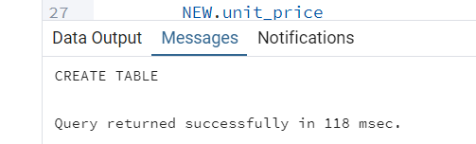

**CREATE OR REPLACE FUNCTION log_price_change()**

CREATE OR REPLACE FUNCTION fn_product_price_audit()

RETURNS TRIGGER AS $$

BEGIN

INSERT INTO product_price_audit (product_id,product_name,old_price, new_price

)

VALUES (

OLD.product_id,

OLD.product_name,

OLD.unit_price,

NEW.unit_price

);

RETURN NEW;

END;

$$ LANGUAGE plpgsql;

**Create trigger function:**

CREATE TRIGGER trg_product_price_update

AFTER UPDATE OF unit_price ON products

FOR EACH ROW

WHEN (OLD.unit_price IS DISTINCT FROM NEW.unit_price)

EXECUTE FUNCTION fn_product_price_audit();

**Output:**

SELECT product_id, product_name, unit_price FROM products WHERE product_id = 1;

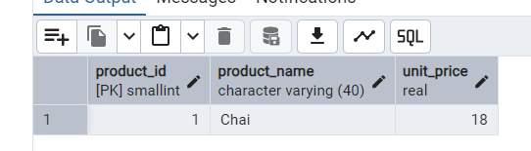

**Update price by 10% and verify the audit log:**

**Query:**

UPDATE products SET unit_price = unit_price * 1.10 WHERE product_id = 1;

SELECT * FROM product_price_audit WHERE product_id = 1;

**Output:**

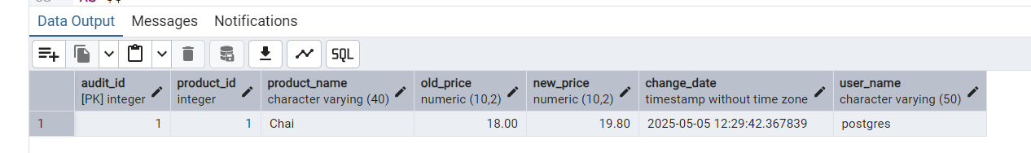

**Q2)** **Create stored procedure using IN and INOUT parameters to assign tasks to employees**

**Create Table:**

**Query:**

CREATE TABLE IF NOT EXISTS employee_tasks (

task_id SERIAL PRIMARY KEY,

employee_id INT,

task_name VARCHAR(50),

assigned_date DATE DEFAULT CURRENT_DATE

);

**Create Table or Replace Procedure:**

**Query:**

CREATE OR REPLACE PROCEDURE assign_task(

IN p_employee_id INT,

IN p_task_name VARCHAR(50),

INOUT p_task_count INT DEFAULT 0

)

LANGUAGE plpgsql

AS $$

BEGIN

INSERT INTO employee_tasks (employee_id, task_name)

VALUES (p_employee_id, p_task_name);

SELECT COUNT(*) INTO p_task_count

FROM employee_tasks

WHERE employee_id = p_employee_id;

RAISE NOTICE 'Task "%" assigned to employee %. Total tasks: %',

p_task_name, p_employee_id, p_task_count;

END;

$$;

**-- First call**

CALL assign_task(1, 'Review Reports', 0);

DO $$

DECLARE

task_count INT := 0;

BEGIN

CALL assign_task(1, 'Prepare Presentation', task_count);

CALL assign_task(1, 'Attend Meeting', task_count);

END;

$$;

**Output:**

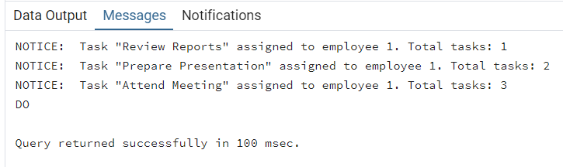

**SELECT * FROM employee_tasks ORDER BY task_id;**

